A pre-proposal to the National Science Foundation to develop a proto-type Low-Cost Autonomous Unmanned Aerial Vehicle (AUAV) platform and instrument package for the Global Albedo Project

December 6, 2002

J. Kosmatka¹ (aircraft) and V. Ramanathan² (Instrument Package)
¹Department of Structural Engineering
²Scripps Institution of Oceanography (SIO)
University of California, San Diego

Co-Investigators:
G. Roberts (C4, SIO- UCSD; instrument design, integration and analysis)
E. Wilcox ( C4-SIO, UCSD.Post-Doc, Cloud and aerosol simulation studies for flights)
J. Panza (Optimum Solutions; aircraft design and navigation systems)
Odelle La Revierre (Grad student, SIO; Instrument design & Data analysis)
Guy Watanabe, Dept of Structural Engineering, UCSD
A. Pham (Under grad student, C4-SIO instrument CAD drawings)

Abstract:

The fundamental objective of the Global Albedo Project (GAP) is to develop a theory and model that will explain how aerosols and clouds regulate the planetary albedo, with particular emphasis on the role of human activities. The Principal investigators for GAP are V. Ramanathan and J. Kuettner. A brief summary description of GAP authored by Ramanathan and Kuettner (2002) has been provided to NSF. As a starting point, GAP will focus on cloud systems over the Pacific Ocean. The first task is to generate a database with simultaneous in-situ observations of aerosols, clouds and cloud albedo. This task requires autonomous unmanned aerial vehicles (AUAV) that have long duration (at least 1 to 2 days) and long range (at least 3 to 4 thousand kilometers) with light instrument payloads (5kg). Such AUAV’s and light cloud and aerosol physics instruments are currently not available. Our strategy is to develop this capability.

This pre-proposal submitted to NSF constitutes phase-A of GAP dealing with feasibility studies. It consists of four steps:
a) Design and develop an AUAV, hereafter referred to as: GAP-PT1 for GAP-Prototype 1;
GAP-PT1 will be similar to the actual aircraft needed for GAP missions to Hawaii, but will not have the range. Its range will be about 200km.
b) Develop a light weight instrument package for GAP-PT1 and integrate it with the aircraft;
c) Flight test GAP-PT1 with instruments within a limited range of about 100 km to 200 km.
d) Provide a design for GAP-FM1(for GAP Flight-Model 1). GAP-FM1 will be similar to GAP-PT1, but will have the full range required for GAP research flights from California to Hawaii. Our current strategy calls for submitting an MRI in January 2003 to build and test GAP-FM1.

We are assembling a team of aircraft designers and builders, instrument experts and atmospheric physicists. The team consists of academics, consultants from aircraft and instrument companies, post docs and students. The cost is $ 119,776 for step-a and step-d; $30,000 for step-b; and $10,000 for Step c. We have secured $25,000 from the Vetelson foundation to C4 and $15,000 from the Alderson Chair funds to V. Ramanathan. We are requesting NSF to fund $ 100,000 K. With an additional $20,000 provided through PI Ramanathan’s NSF grant, the two NSF funds will fund steps-a and d, i.e., design and build GAP-PT1 and design GAP-FM1. If funded by Dec 15, we expect the aircraft to be ready for flight testing by June 15, 2003.

Part –A: PI: J. Kosmatka

Development of a Low-Cost Autonomous Unmanned Aerial Vehicle (AUAV) for Atmospheric Monitoring Experiments. To be funded by $100,000 from NSF.

A.1 Background

Autonomous Unmanned Aerial Vehicles (AUAVs) are aircraft that are not directly ground controlled. The complete vehicle and payload mission are defined and programmed into the vehicle during preflight set-up. This vehicle mission includes take-off, cruise speed, destination or turn-about points from global positioning satellite (GPS) coordinates, loiter information, and landing coordinates. The payload mission typically involves visual or infrared cameras, receiving/ transmitting antennas, and/or science sensors. The payload mission can be either passive so that it does its job independent of the programmed vehicle mission, or it can be active, so that it alters the vehicle mission as needed. Military developed UAV’s, which cost $3M to $100M, can actively change their flight path based upon inputs from on-board sensors. But these military vehicles are much too expensive for nonmilitary applications. What is needed is an AUAV in the $20K to $75K range (finished replacement cost) that can be used by scientists performing atmospheric monitoring experiments).

The University of California, San Diego (UCSD) has been involved with developing UAV’s for the past four years. This development has involved looking at a wide range of designs for different payloads, and different structural manufacturing options to reduce cost. The aircraft have been built and flown in international university competitions. In the past three years, the UCSD aircraft have taken 6th, 4th, and 1st place in these competitions. Examples of UCSD competition aircraft are shown in Figure 1. The aerodynamic platform of the aircraft is developed with the aid of computational modeling techniques. The aircraft performance and stability are developed and checked using UCSD developed software. Finite element modeling is used to size the structural components and check stiffness and strength requirements. These aircraft are constructed from a variety of composite materials (graphite/epoxy, glass/epoxy, Kevlar/epoxy) to produce a very strong lightweight vehicle. The propulsion and power management systems involve using modified electric motors and specially designed propellers. The UCSD team has received valuable assistance from a wide variety of local aerospace engineering and R/C aircraft experts.
2001/2002, 1st Place
“National Champion”
2000/2001, 4th Place

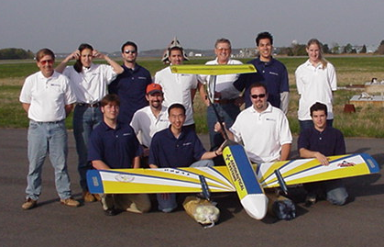
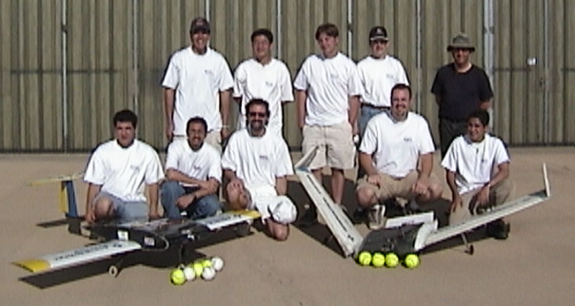

Figure 1: UCSD AIAA Student Chapter Competition Aircraft (a) 2000-2001, and (b) 2001-2002.

Currently, a fully autonomous aircraft is being developed, by UCSD (Kosmatka) and Optimum Solutions (OS; Panza)), which will serve as a long-range extended loiter observation and monitoring platform. This aircraft is referred to as UCSD/OS-E² (for Eagle Eyes). Its overall view and fuselage detail is presented in Figure 2. The aircraft has full autonomous capabilities so that its complete flight plan (take-off, climb, cruise, loiter, and land) can be programmed into the aircraft. Thus, a true low-cost Autonomous Unmanned Aerial Vehicle (AUAV) will be available for observation and scientific missions. The aircraft will be built entirely with composite materials. Most of the components will be changeable, including wing tips, horizontal and vertical tail, landing gears, engine and engine cowling. The fuselage is composed of three sections, where the front section contains the payload (visual and infrared cameras up to 1 kg), the middle section contains the autopilot, flight control hardware, ballistic parachute and homing device, and the rear section contains the power plant. The ballistic parachute and homing device will be deployed when the vehicle deviates from its allowable flight envelope. The fore and aft sections of the fuselage can be easily changed for different payload and propulsion systems (four-stroke gasoline engine, electric motor). The wings are composed of three parts; the central wing, which is, mounted between the carbon fiber fuselage booms, the main wings, and the wing tips. Both the main wings and wing tips can be replaced for different payload and mission requirements. The main landing gear will be mounted between wing spars (central wing) and it will retract into the central wing. The nose landing gear will be mounted in the nose of the airplane and it will retract into the fuselage. Missions up to 400 miles are planned for this vehicle including round trip flights from San Diego to the Channel Islands. See Figure 3.
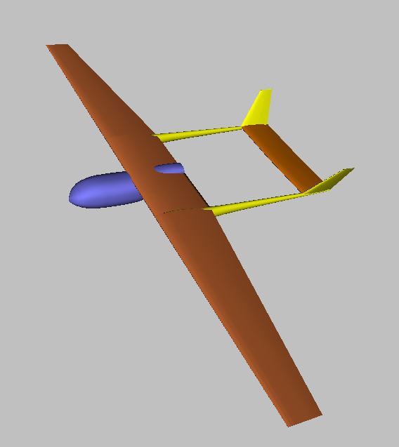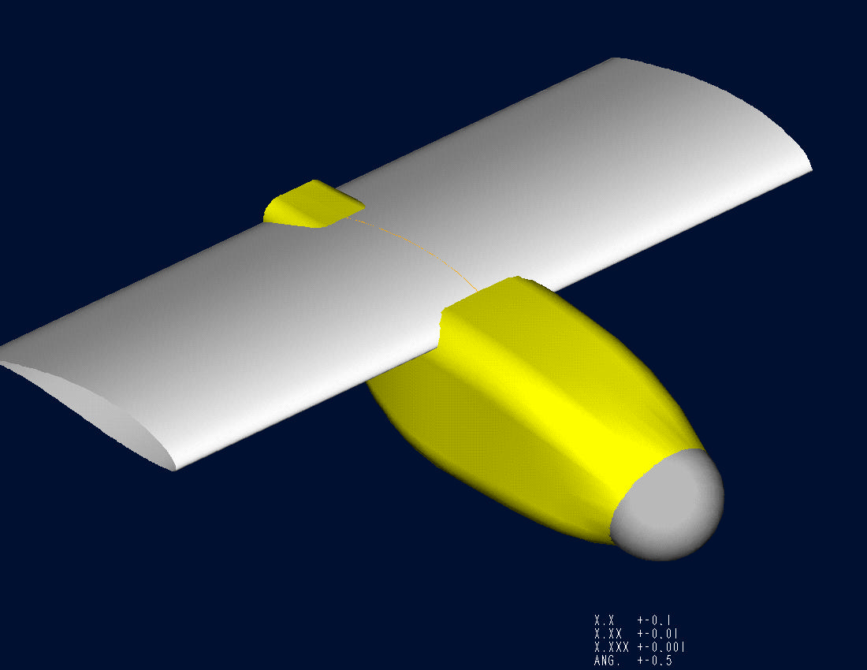

Figure 2: UCSD/OS-E² AUAV (a) overall view and (b) fuselage detail showing front mounted visual and infrared camera window.

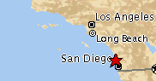
Channel Islands

Catalina Island

Figure 3: Proposed Flight Plan for UCSD/OS-E² Observation AUAV

The design of the UCSD/OS-E² aircraft has the following characteristics:
- Complete Wing span: Variable from 1.5 m (60 inches) to 3 m (118 inches)
- Center wing span: ~50.8 cm (~20 inches)
- Gasoline engine: ~24-28 cc
- Fuselage diameter: 15.2 cm (6 Inches)
- Fuselage length: 54 cm (21 inches)
- Flight Endurance: 2-18 Hours (depending upon propulsion system and payload)
- Minimum Speed: ~30 mph
- Pusher configuration.
- Dual Booms
- Replaceable wing tips, horizontal and vertical tails, landing gear, engine, and cowling
- Amphibious capability
- Instrument payload capacity 1 Kg
Maximum gross weight will be approximately 10 Kg (~22 lbs). The autopilot computer and GPS navigation system and required software are being jointly developed by UCSD and Optimum Solutions. An example of the proposed autopilot software, which is shown in Figure 4, includes flight maps (for example, the Mission Bay area of San Diego). The avionics characteristics include:

- Complete autonomous operation including take-off, climb, cruise, and landing.
- Turn coordination with 20 degree per second turn rates
- Altitude and Airspeed hold.
- Multiple waypoint GPS navigation including in-flight override
- Extensive data log capability, Almost real time telemetry capabilities
- Manual override for ground pilot control
- Option for in-flight satellite call-up and connection

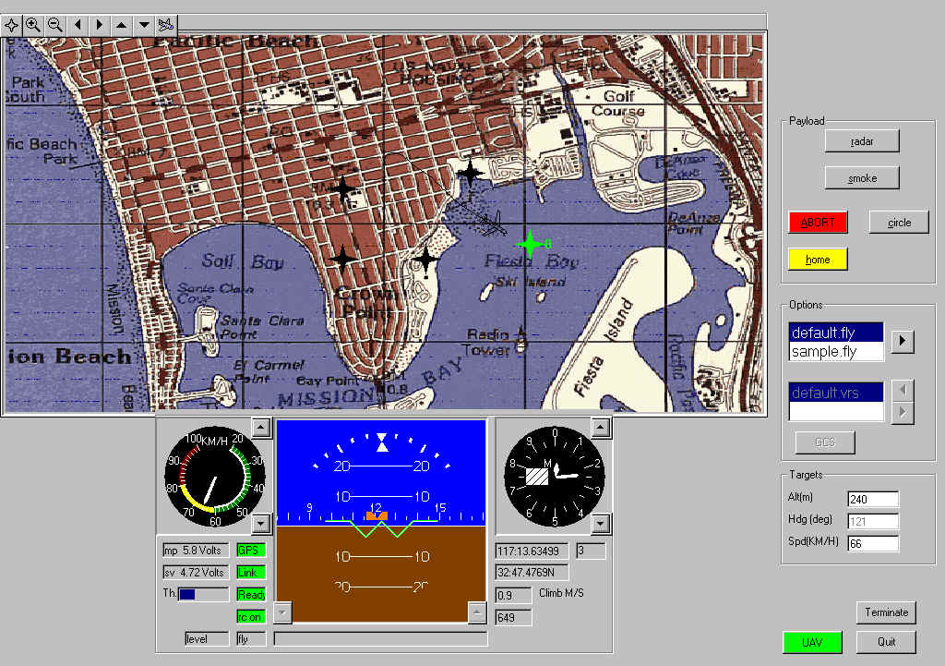

Figure 4: Proposed Auto-Pilot Software with programmable take-off, landing, and way points based upon GPS and altitude information (map of Mission Bay of San Diego is shown).

A.2 SPECIFIC STEPS

The proposed aircraft development project for GAP is a 6-month design and build effort followed by a 2-month flight tests and missions. The project consists of the following steps :
(1) Develop a low-cost AUAV (GAP-PT1) for carrying GAP instruments (see Part B) by focusing the development of the above UCSD/OS-E² aircraft to carry heavier (5 kg) and larger payloads on shorter (200 km) missions, (2) Fabricate the GAP-PT1 fully autonomous aircraft to carry these instruments, (3) Develop the autopilot and software system to support the proposed aircraft mission, (4) Demonstrate the capabilities of the aircraft on a programmed off-shore scientific flight mission (pending FAA approval or exemption), and (5) Design the GAP-FM1(Flight Model 1; the long range version of GAP-PT1) AUAV for a longer mission (San Diego to Hawaii) based upon the design features of the current aircraft design. The resulting aircraft will have low operation and maintenance costs, will be multifunctional with exchangeable fuselage sections, and will have complete autonomous operation with minimal supervision. The fabricated aircraft (GAP-PT1) will be devoted only to the GAP program and basic autonomous flight research during the GAP grant period.

A.3 SCHEDULE

The proposed effort will follow the time schedule outlined below:

- Aircraft Design (GAP-PT1; the 200 km range AUAV): The aircraft design will be completed based upon the flight envelope requirements and the payload definition (5 kg of scientific instruments in a defined geometric envelope). This will include designing the forward section of the fuselage to carry the proposed atmospheric sensing instruments. An off-the-shelf four-stroke gasoline engine will be selected as the power plant. A foam mock-up of the complete aircraft will be constructed to use in the design process for placement of all the flight and scientific instrumentation (month: 1 and 2)
- Aircraft Design (GAP-FM1; the long range version of GAP-PT1): An AUAV aircraft will be designed for longer-range missions (one-way nonstop from San Diego to Hawaii) based upon the low-cost approach of GAP-PT1. Initially, payload trade-off studies will be performed to estimate the aircraft size and cost as a function of payload weight and geometry, where aircraft propulsion system costs will be based upon identifying existing commercially available powerplants. Thus, the need for smaller payloads will be understood. A worst-case payload definition from the GAP-PT1 (5 kg of scientific instruments in a defined geometric envelope) will be considered as the baseline in the design studies so that the forward fuselage will be identical. The propulsion system will be sized, including the identification of an existing off-the-shelf four-stroke gasoline engine, design of the propeller, and the sizing of the fuel tank. Additional instrumental details for the Hawaii mission will be investigated, such as instrumentation stabilization and satellite cellular telephone capabilities for mission abort. At the end of this phase, the costs, construction time, and constraints for developing GAP-FM1 will be fully understood. A foam mock-up of the complete aircraft will be constructed to use in the design process (month: 1 and 2).
- Aircraft Fabrication: The aircraft structure of GAP-PT1 will be constructed of advanced composite materials using existing materials, tools, and equipment at UCSD. The propulsion system (engine) will be installed, and fuel tanks and propeller will be selected based upon a 200 km Southern California offshore flight mission. (Month: 3, 4, and 5).
- Auto-Pilot Development, Calibration, and Training: The auto-pilot development will be validated using a trainer R/C aircraft and doing long-term flight testing in the California high desert. (Month: 3, 4, and 5).
- Autonomous Vehicle Transformation: The autopilot and navigational system will be installed in the aircraft and initial flight-testing will begin. Initial tests will be performed in the high desert northeast of Los Angeles (near the General Atomics flight center) to prove out the airplane performance, autopilot, and power management. (Month: 6 and 7)
- Flight Testing and Scientific Mission: After completion of the initial flight tests, a series of longer-range (200 km) offshore flight missions will be flown. Scientific data will be taken during the flight. The particular flight path is dependent upon either FAA approval or exemption. Alternative flights off the Mexico coast will also be considered. (Month: 8)
- Project Summary: Post-flight information will be used to evaluate the aircraft performance and make recommendations for future low-cost AUAVs.
Part A, Continued (PI: J. Kosmatka)
Proposed Budget for GAP-PT1 and GAP-FM1

Labor
Faculty (1 month summer salary) $ 9,211.
Benefits (12.7% summer salary) $ 1,170.

One Graduate Student ($995/month academic, $2957/month summer) $ 9,924.
Tuition Remission ($1185/month – 7 months) $ 8,295.
One Undergraduate Student ($1,807/month – 2 months) $ 3,614.
Benefits (1.13% academic, 3% summer) $ 179.

Consultant (8 months, 25% time) $25,000.

Structural Engineering Department Tax ($866.7/month) $ 6933.

Total Labor: $64,326.

Equipment
Structural Materials $ 5,000
Propulsion System (Gasoline engine, 3 propellers, fuel tank, etc) $ 1,000
Transmitter, receiver, servos $ 2,000
Navigational Equipment $ 8,000
Laptop Computer $ 4,000
Analysis Software $ 2,000

Total Equipment: $22,000

UCSD Overhead (52% on non-equipment) $33,450.

Total: $119,776.

Part B: Scientific Instruments to be integrated and flown during the testing phase
PI: V. Ramanathan;
Co-I: G. Roberts

B. 1 Introduction

The unmanned platforms (AUAV) described in Part A of the proposal require payloads less than 5 kg and instruments that are sufficiently small to be integrated into the aircraft design. To address the fundamental objectives of this proposal, we will equip the AUAVs with a minimal set of instrumentation to study aerosol/cloud/climate interactions. The instruments will measure aerosol concentrations and size distributions, cloud condensation nuclei concentrations, cloud droplet concentrations and size spectra, and incoming and reflected solar radiation. Table 1 lists the instruments that will be deployed and outlines their estimated weight and power requirements. All instruments have been included for completeness; and those marked with (**) will not be integrated in PT1 during the first phase of this project. A minimum set of instrumentation has been chosen to reduce the payload to less than 5 kg per plane to minimize development and operational costs associated with larger aircraft missions. The weights have been estimated based on miniaturization efforts and discussions with individual companies. The instruments will be interfaced to an onboard computer data acquisition system.

Instrument | ID | Est. weight  (kg) | Power  (W) | Data acquisition
Condensation Particle Counter 3007 | CPC | 0.75 | 15.0 | RS-232
Optical Particle Counter | OPC | 0.30 | 5.4 | RS-232
** Cloud Droplet Probe | CDP ** | 2.20 | 15.0 | RS-232
Pyranometer | CM21 | 0.75 | 0.1 | datalogger
** Narrow-band radiometer  (415, PAR, 875 or 780, 550) | BSI ** | 0.30 | 0.1 | RS-232
** Cloud Condensation Nucleus Counter | CCN ** | 3.00 | 20.0 | RS-232
digital camera | DC | 0.50 | 0.1 | Internal storage
data acquisition system | DAQ | 0.50 | 10.0 | --
aerosol inlet | AI | 0.50 | 0.0 | --
Estimated payload for each platform |  | Payload  (kg) | Power  (W) | Instrumentation
above-cloud |  | 4.65 (4.05)⁺⁺ | 30.9 | AI, DAQ, CPC, 2*CM22, OPC, 2*BSI, DC
in-cloud |  | 3.95 | 45.4 | AI, DAQ, CPC, CDP
below-cloud |  | 5.35 | 45.2 | AI, DAQ, CPC, CCN, 2*BSI

Table 1. Instrumentation for the autonomous unmanned aircraft. The above-cloud aircraft measures aerosol concentration and cloud albedo; the in-cloud aircraft measures aerosol concentration and droplet distribution; the below-cloud aircraft aerosol concentration, cloud condensation nuclei and transmitted solar radiation.

** These instruments will not be ready for deployment during the initial phase of the project, but have been included in the table for completeness.

⁺⁺ The weight in the parentheses represents the payload without the BSI sensors – during the first phase of this project.
A brief description of the instrumentation and their deployment is outlined below:

Condensation Particle Counter – TSI 3007

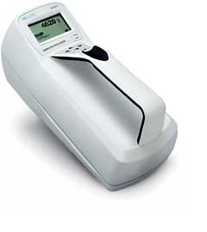The condensation particle counter (CPC) measures total particle concentrations between 0 and 10⁵ cm⁻³ (Dp > 10 nm). Screen diffusers may also be stacked at the inlet of the CPC to select the minimum cutoff diameter from 0.01 to ca. 0.3 micron. This will be useful in determining number concentrations of aerosol that are important for light scattering. Aerosol particle from 0.1 to 0.3 micron may also be efficient as cloud condensation nuclei.

To reduce weight and volume, the external packaging will be removed and the sensor and electronics will be mounted in fuselage, and sample line attached to aerosol inlet. The CPC engine be arranged such that the optics is pointing towards the nose of the vehicle and mounted as upright as possible. This is to prevent flooding of the optics chamber during take off.

Optical Particle Counter – MetOne

The optical particle counter (OPC) measures total particle concentrations for diameters larger than 0.3 micron in six size channels. Particle distributions between 0.3 and 10 micron will be obtained. To reduce weight and volume, the external packaging will be removed and the sensor and electronics will be mounted in fuselage.

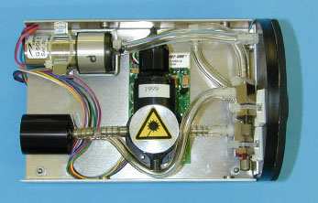

CM21 Pyronameter – Kipp & Zonen

The pyranometer measures total hemispherical solar radiation (0.305 – 2.8 micron) and will be deployed on the above-cloud platform. Upward and downward facing sensors will be mounted on the fuselage or wings. The picture below shows the off-the-shelf package. We are currently redesigning the sensor housing to achieve a smaller, aerodynamic design. Instrument performance and stability will be tested using computer modeling. The final phase will involve mounting the pyranometer on a stabilizing platform that maintains a horizontally level plane.
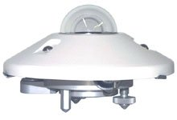

B. 2 Research Objectives

The proposed research effort will focus on miniaturization and integration of aerosol and radiation instruments for deployment on the unmanned aircraft. The specific goals are to: 1) integrate aerosol instrumentation (inlet, CPC, OPC) into aircraft; 2) test the performance of the aerosol inlet; 3) repackage and performance testing of pyranometer for airborne deployment; 4) demonstrate autonomous operation of the instruments. The payloads will reflect that of the above-cloud platform.

B.3 Research Plan

Our initial efforts will focus on the integration of instruments that are readily available, relatively cheap and easily deployed on the aircraft. During the first phase of development, the above-cloud payload will be developed. The proposed instrumentation development plan has the following steps:

1. The CPC and OPC are readily available and relatively easy to integrate into the aircraft design. Computer-aided drawings (CAD) have been obtained and will be used to design the fuselage. (3 months)

2. An aerosol inlet will be mounted on the fuselage to allow unbiased sampling of aerosol concentrations and size distributions. Obtaining unbiased aerosol samples requires a well-designed inlet suited for the airborne platform. The inlet must be designed to obtain isokinetic and isoaxial samples outside the influences of the aircraft. (3 months)

3. The existing radiation instruments (i.e., the pyranometer) need to be repackaged and tested before deployment. The airborne version of the CM21 will be designed and modeled with CAD software to provide an aerodynamic package that can be mounted on the wings or fuselage. The integration of the CM21 will complete the design for the above-cloud platform. (3 months)

4. Offshore flight missions will test the autonomous operation and validity of the data obtained from the aerosol and cloud instruments. Post-flight information will be used to evaluate instrument performance and expose necessary modifications.

Proposed Budget

Condensation Particle Counter (CPC) | $8,750
Repackage pyranometer | $10,000
Optical particle counter (OPC) | $1,750
Aerosol Inlet | $8,000
Data Acquisition System | $2,000
Analysis Software | $2,000
Instrument Integration & Operation | $7,500

Instrumentation and integration costs of $40K will be paid from Vetlesen and Alderson foundation funds. Pending the deployment of the aerosol inlet and integration of aerosol instruments, we may divert funds from the repackaging of the pyranometer to cover these costs.

